VOSA GROUP OF COMPANIES (VOSA)
Professional freight forwarding and shipping agency.
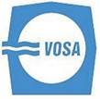

our history  - VOSA GROUP OF COMPANIES (VOSA) - a member of Vietnam National Shipping Lines (VINALINES) was established in 1957 in Haiphong and moved to Hochiminh City in 1993.  In 2006, our company has been equitized from the State-owned company to the Stock - Holding Company (Public Company) in which the main shareholder, Vinalines, holds 51% of the Charter Capital, other shareholders, the english and foreign investors including our staff, hold 49%. VOSA is one of the first shipping agents in the Vietnam Shipping Industry. VOSA head office is located in Hochiminh city and has its national network of 14 branches offices at all ports of Vietnam and Hanoi capital such as: VOSA Saigon, VOSA Danang, VOSA Quinhon, VOSA Nhatrang, VOSA VungTau, VOSA CanTho, VOSA Hanoi, VOSA Quang Ninh, Vosa- Orimas…  - Our jointed Stock companies: China Shipping(Vietnam) Ltd, NYK Line (Vietnam) Ltd, SYMS (Vietnam) Ltd and as shipping agent for Namsung Shipping Co.,Ltd, Sinotrans.  member of associations  We are a full member of:  - The Baltic International Maritime Council (BIMCO)  - International Federation of Freight Forwarders Associations (FIATA)  - International Air Transport Association (IATA)  - Vietnam Chamber of Commerce and Industry (VCCI)  - The Vietnam Ship Agents and Brokers Association (VISABA)  - The Vietnam Freight Forwarding Association (VIFFAS) | our services
  + Shipping Agency :
  - Shipping agent for SINOTRANS lines.
  - Port Agency service for all type vessels ( at port or offshore )
  - Husbandry attendance, Stevedoring, Handling claims
  - Bunkering and Provision supply, Crew change
  - Hospitalization and repatriation.
  + Ship Brokerage:
  - Canvassing cargo , chartering , ship brokering.
  + Freight Forwarding/ Logistics :
  - Sea and Air freight
  - Customs clearance.
  - Project cargo handling
  - Door to door service, Tallying:
  - Inland transhipment
  - Consolidation and warehousing
  - Customs Bonded Warehouse, Border trading ...

our offices
VOSA - HAI PHONG:
SINOTRANS LINES.
Add:54 Le Loi Str., Ngo Quyen Dist., Hai Phong City, Vietnam
Tel: + 84.22- 53550671
Fax: + 84.22 -53855444
VOSA - HA NOI:
SINOTRANS LINES.
Add: R707-709, 7Flr; Ocean Park Building, 01 Dao Duy Anh, Dong Da Dist; Hanoi City, Vietnam
Tel: +84.24-35746621
Fax: +84.24-35746620
VOSA HOCHIMINH:
SINOTRANS LINES.
Add: 5th Floor, Petroland Tower, 12 Tan Trao Street, Tan Phu Ward, District 7, Ho Chi Minh City, Vietnam.
Tel: +84.28-54161820
Fax: + 84.28-54161823
VOSA- DA NANG:
Add:52 Pasteur St., Hai Chau Dist, Da Nang City, Viet Nam
Tel: +84. 236-3821161
Fax: +84. 236-3822426

OUR ABILITIES
-WAREHOUSES:
-TRUCKING
Location | Trailors | Vans
HO CHI MINH | 10 Units | 5 Units
DA NANG | 5 Units | 2 Units
HA NOI |  | 2 Units
HAI PHONG | 10 Units | 5 Units

contact with us  VOSA GROUP - HA NOI OFFICE:  SINOTRANS LINES.  Add: R709, 7Flr; Ocean Park Building, 01 Dao Duy Anh, Dong Da Dist; Hanoi City, Vietnam  Tel: +84.24-35746621  Fax: +84.24-35746620  Website: http://vosa.com.vn/  Email:Saleshn01.orimas@vosagroup.com  Cell phone +84 936318169  PIC: Robert Vu     | OUR OVERSEA PARTNERS  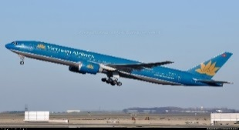  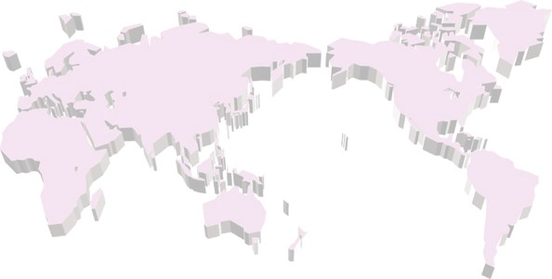  VOSA’S agents (Australia & New Zealand)  VOSA’S agents (Americas)  VOSA’S agents (Africa)  VOSA’S agents (Asia)  VOSA’S agents (Europe)  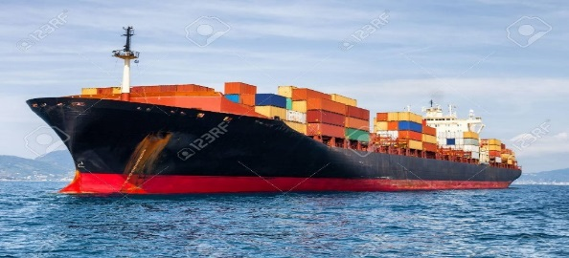

Don’t hesitate to contact with us!

