Home:
Welcome to our website designed primarily to serve and facilitate all your business needs for shipping export, import & agency requirements as we believe that your success is ours. We trust that every single move our customer takes has to be evaluated carefully and that’s why we are putting all our knowledge and expertise to make sure that you have a 100% accurate evaluation that will play a role in the success of your business. We tried to put as much information as possible here and of course if there is any additional information or assistance needed you are kindly requested to contact us by e-mail or by phone and it will be our pleasure to serve all your business needs.
Working firm Shaden Shipping & Trading as a customs clearance and navigation works and customs services and integrated logistics system, company was founded in 2000 by Mr. / Mahmoud Mohamed EL Sayed Abbas and The company enjoys system provides accuracy and ease of follow-up developed by system (ONTIME SYSTEM).
Shaden Shipping And Treading Co, is now in Switzerland
Accompanied by our belief in providing unique and complete business services to importers and exporters, we are proud to be the first logistics company to provide complete business services starting from accommodating our clients in Switzerland and connecting them with suppliers to delivering the goods to the receiver’s premises.
dangerous goods and machinery giant factories and major projects.
The main markets that deal with the company are:
All GCC markets, Yemen, Lebanon, Libya, Iraq and the Arab Maghreb countries and Eastern Europe through the sales agents and distribution in the State of switzerland. The company wants to open new markets through agents and customers all over the world.

Profile:
The Department of Export specialized integrated development of exports of Egyptian marketing of Egyptian products in foreign markets, Arab and foreign countries.
Flavor, since it is based:
* Most of the factories producing biscuits, chocolate and chewing gum and candies.
* Export and natural juices and carbonated soft drinks.
* Export of agricultural products of cereals, pulses and vegetable oils and medicinal herbs to the Arab countries and Europe.
* Export of plastics manufacturer.
* Export of Egyptian rice of all kinds
* Export all summer and orange fruits and vegetables Egyptian
WHY DEAL WITH THE FIRM SHADEN SHIPPING & TRADING CO.,?
WE:
• familiar with the Egyptian law.
• know the regulations and how to deal with the bodies and individuals in Egypt.
• know how to make the best choice to accomplish each task.
• We have alternative plans and team work to solve any emergency problem.
• familiar with all the information and procedures in the field of customs clearance and shipping and logistics services in Egypt.
• We have a team with high efficiency practically and scientifically through studies and lectures by lecturers and academics and also through training courses in customs clearance.
• We can negotiate the best purchase prices from suppliers and factories foreign company through our agents abroad.
• Dealing with shipments drawback, temporary admission, re-export and reform / replays.
• end the necessary procedures for shipments of free zones and contained for tourism projects and goods subject to the Investment Law, galleries, government agencies, embassies, whether goods are exempt from customs duties or enjoying reduced fees.

Services:
Export of all agricultural products, fresh, chilled -
Export of wood products and furniture Khan el-Khalili -
Export to the detriment of others peer commission -
Import frozen meat -
Import for the account of others peer commission-
• customs clearance of goods imported and exported through all customs ports and marine air and land next to documenting service official documents from government agencies, embassies, ministries, and check presentations on exports, imports and screening plants, agriculture, pharmacy, and other bodies.
• Shipping and Berri for all incoming and outgoing shipments.
• full container shipping and container joint sea and land.
• general cargo, containers and common goods and car shipping service.
• Internal transport of incoming and outgoing cargo (LCL and common) and refrigerated cargo service.
• Check trans-shipments of all ports and dry ports.
• Dealing with shipments drawback, temporary admission, re-export and reform / replays.
• End the necessary procedures for shipments of free zones and contained for tourism projects and goods subject to the Investment Law, galleries, government agencies, embassies, whether goods are exempt from customs duties or enjoying reduced fees.
• Shipping and transportation of samples and personal luggage and small letters and dangerous goods and machinery giant factories and major projects.

PRODUCTS EXPORT :
FRESH ORANGE FRESH MANGO ARTICHOKE
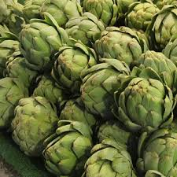
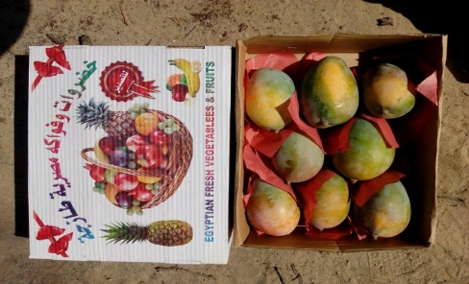


FRESH GUAVA EGGPLANT BLACK ABBRGIN
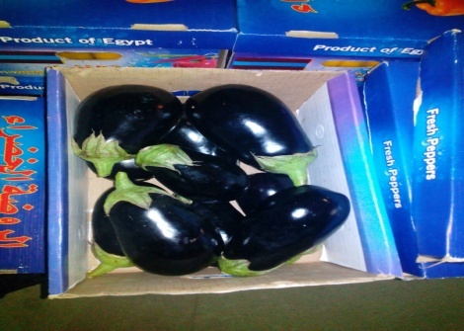
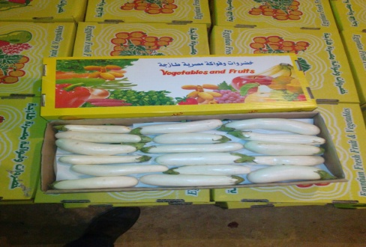
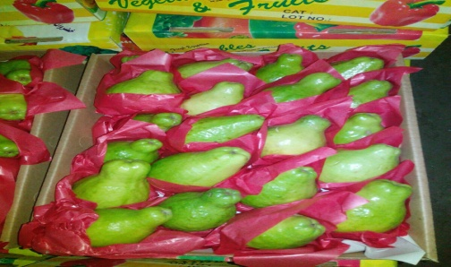

FRESH LEMON FRESH STRAWBERRIES GRAPE FLIM
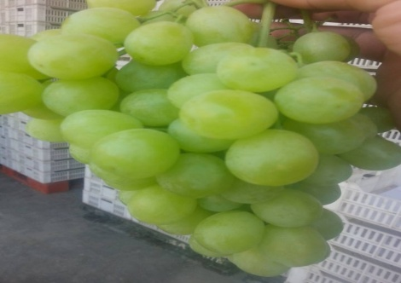
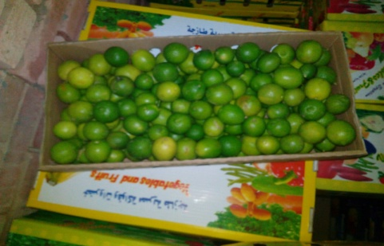


KHAN AL-KHALILI KHAN AL-KHALILI KHAN AL-KHALILI
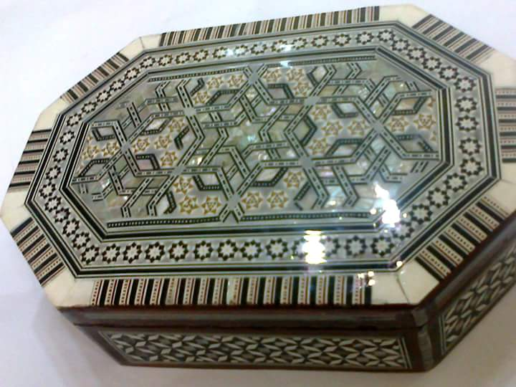



Contact us:
Chairman:
MR : MAHMOUD ABBAS
MOB: +2 01228286724
MOB: +2 01010085453
EMAIL: CHAIRMAN@SHADEN-SHIPPINGCO.COM
CLEARANCE MANAGER :
MSS : ESSRA QUNDIL
EMAIL : INFO@SHADEN-SHIPPINGCO.COM

HEAD OFFICE: 4 Mitrases St., Next To a Bakery Siam Second Round Wardian Alexandria
TEL: ( +2)034451780 Ext 101 , 102
FACEBOOK: https://www.facebook.com/Shaden-Shipping-And-Trading-Co-273790129301905/?ref=hl
TWITTER : https://twitter.com/MAHMOUD17635041

